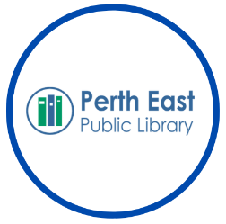

Parks Pass Lending Policy

Statement of Purpose
This policy outlines the conditions for lending the Ontario Parks Day-Use Permits and the Grand River Parks membership. These passes will provide patrons with complimentary day-use access (does not include camping fees) for one vehicle (excludes buses) and its occupants at more than 100 provincial parks and 11 Grand River Parks. These permits will be accompanied by additional library resources and activities to educate Perth East residents on the natural and cultural history of Ontario.

Terms of Use

Who can Borrow
Any Perth East Public Library cardholder age 18+ with an account in good standing can checkout a parks pass.
Households (households are accounts that are registered at the same address) are permitted to have one permit out at a time.
These permits will not circulate to other PCIN loaning libraries.

Lending Period
Ontario Parks Day-Use Vehicle Permits and the Grand River Parks membership are available for a 7-day loan period, and are not available for renewal. This will ensure as many people as possible get a chance to use these permits.
Households are permitted to have one active hold on a pass at a time.

How to Return
Ontario Parks Permits and the Grand River Parks membership should be returned in person to the circulation desk during library operating hours, in the booklet it was received in. This will ensure the permit does not get lost or damaged.

Overdue and Replacement Fees
There is a $2.00/day overdue fine for Parks Permits/Passes.
The replacement cost for a lost Parks Permit is $200.00
We encourage the community to visit Ontario Parks or the Grand River Conservation Authority to plan their visit!
By checking out an Ontario Parks Permit you agree to the Terms and Conditions.

